Danny Ly

Assignment 4

Backpropagation

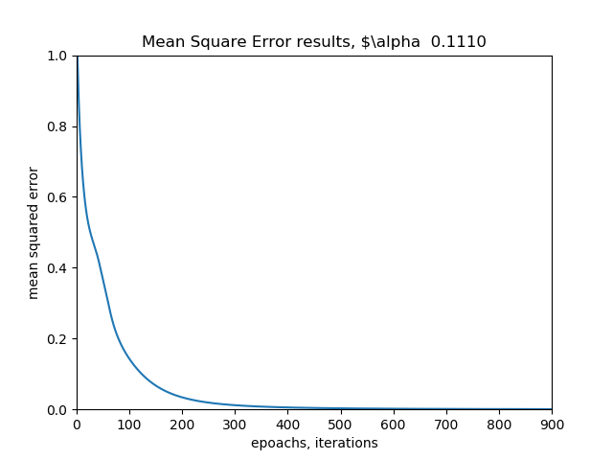

The above is a learning rate of, the algorithm, we can see that with a smaller learning rate our performance convers with more iterations, this could be because the gradient decient needs some time to 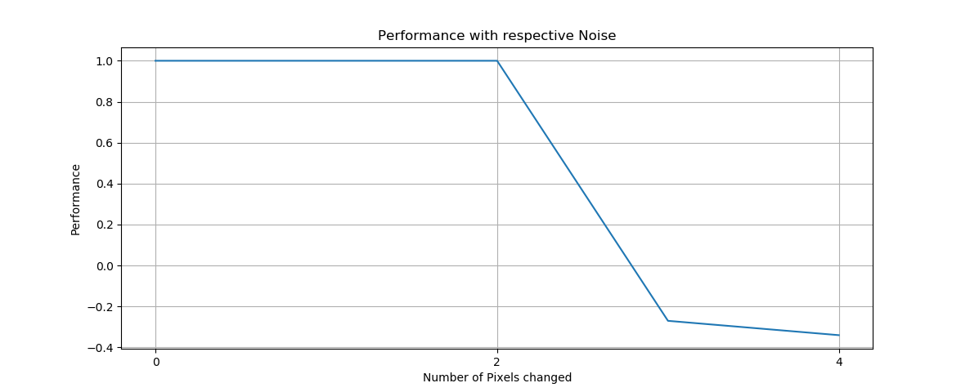

Giving noise we can see that the noise affect the network farly well with more pixels changed the performance starts to decrease , anywhere with cnanges from 2 pixels the performance will start to go down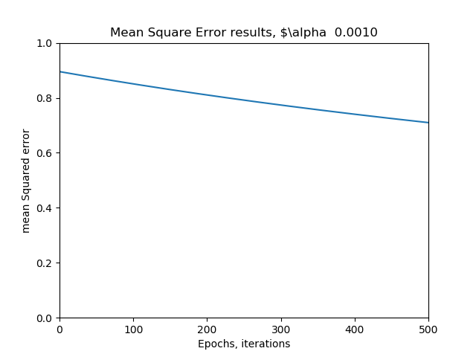

As we can see with a lower leaning rate our network performances worse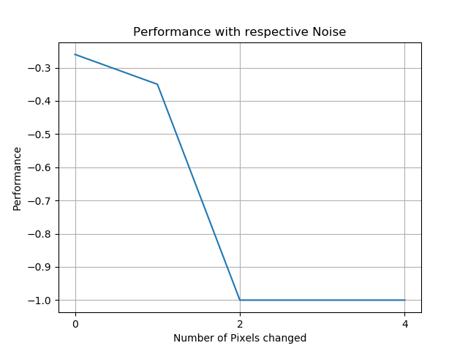

Analysis: during my analysis I compared the cases when we use a large learning rule .10 vs a smaller one .001, as above the graphs show the number of epoachs that it takes for the network to start learning the pattersn and estimating the function better. We can see that a larger learning rule allows lower epoachs to use in learning, this could be because the patterns are so close, that getting the function estimate is easier with this problem smaller learning rates, makes learing very incrementally small, which explains